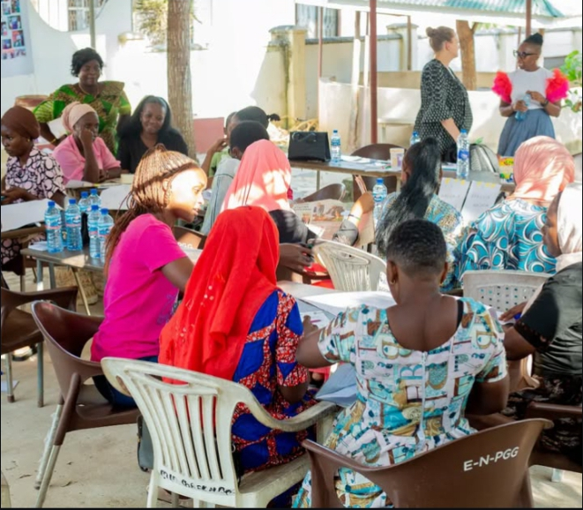
- TESTIMONIES AND CURRENT OUR ORGANIZATION NEEDS TO CONTINIUE WITH THE WORK

As Organization, addressing economic challenges requires comprehensive strategies that tackle the root causes of gender inequality, including promoting equal pay, improving access to education and training, enhancing women's participation in decision-making processes, and implementing supportive policies and programs to mitigate the impact of unpaid care work..

Focusing on our Organization strategic plans, and our result report, up to now, we only achieved 39% of what we envision to do, because we lack resourceful skills, supportive funds and abilities to sustain the development less advantages girls of our community

In response to prevailing needs, some highlighted above, the previous strategic plan (2022-2026) had five results areas termed as strategic goals, shown below: Despite the fact that Tanzania Youths competence for community did not secure comprehensive funding support in terms of financing the whole strategic plan, still through some program and projects, it managed to achieve number of results, which all demonstrated emerging change and targeted issues pursued, instance:

STRATEGIC PLAN  Empowerment for girls, young women and youths, to become capable and resilient enough to excel in self-employment, entrepreneurship, and self-awareness. | STRATEGIC GOAL ACHIEVED  At least 500 direct and indirect reached over 3 years, through social media platform, through our programs, BILA BANDO, , HAINA KUSHINDWA, KIBUBU KIDIGITALI of self-awareness and financial literacy empowerment.
GOAL 2  Creating convincing environment for girls, young women and youths- entrepreneurs to develop and sustain their economic growth | GOAL  TYCC support establishment of (3)young women financial groups (Kibubu ladies, Kibubu Queens and Kibubu masters ) at Kisarawe and Dodoma districts. Enriched (100) students and created KIBUBU STUDENTS CLUB in Geita region.
GOAL 3  Develop and sustain their economic growth through SMART digital finance tools and skills.- KDC initiative.  . | GOAL  Designing simple, and suitable digital savings model for girls entrepreneurs to strive in mobilizing capital Established (1)Entrepreneurship and opportunity center in Nyanghwale district for young women to access economic opportunities, skills, and market.
GOAL 4  Strengthening policies for girl’s young women, and youth’s entrepreneurs. | GOAL  Rising voice and strategy with women movement cumulative efforts in our communities, to expose, earn and impact girls to have voices.
GOAL 5  Tanzania Youths Competence for Community Capacity Improved | GOAL  Achieved few Internal and external Tycc volunteers empowerment

- Our Organization needs support through mentorship, capacity building trainings on resource mobilization, empowerments on effective communications and partnership engagements, and mostly important Funds for its sustainability

KIBUBU KIDIGITALI TESTIMONIES
TYCC basis agenda to empower women financially contributes to the well-being of their families and communities, creating a ripple effect of positive change.
And hence enhance social and community Impact: Some girls from KIBUBU GROUPS improved their small businesses, and professional goals:

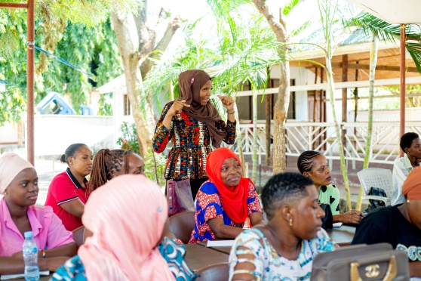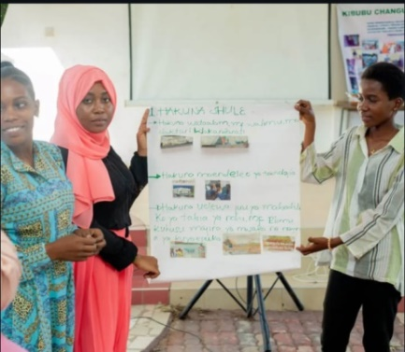
Through structured mentorship and training in financial literacy and digital marketing, Latifa;s cake business were able to transition to online sales, increasing her capital digital revenue by 15% and securing grants, and Aziza effort to pay for her higher education fee, move into reality.

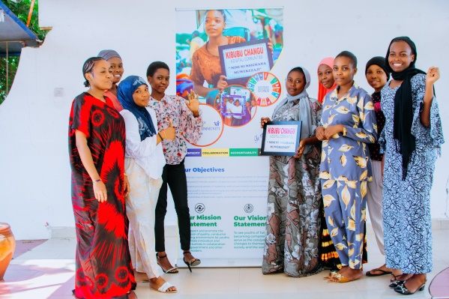Amina, leader of KIBUBU Queens group, was nominated by TYCC for training the stawi lab training which provided business and leadership empowerments

